Lab - Configure Server-Based Authentication with RADIUS (DAYUTH THY)

Topology
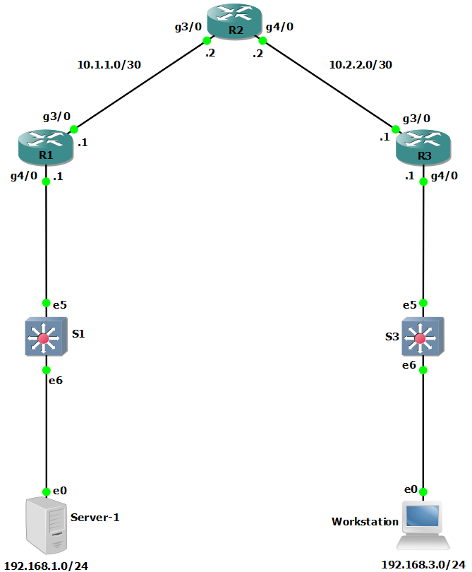

Addressing Table
Device | Interface | IP Address | Subnet Mask | Default Gateway | Switch Port
R1 | G3/0 | 10.1.1.1 | 255.255.255.252 | N/A | N/A
R1 | G4/0 | 192.168.1.1 | 255.255.255.0 | N/A | S1 E5
R2 | G3/0 | 10.1.1.2 | 255.255.255.252 | N/A | N/A
R2 | G4/0 | 10.2.2.2 | 255.255.255.252 | N/A | N/A
R3 | G3/0 | 10.2.2.1 | 255.255.255.252 | N/A | N/A
R3 | G4/0 | 192.168.3.1 | 255.255.255.0 | N/A | S3 E5
PC-A | NIC | 192.168.1.3 | 255.255.255.0 | 192.168.1.1 | S1 E6
PC-C | NIC | 192.168.3.3 | 255.255.255.0 | 192.168.3.1 | S3 E6
Blank Line, No additional information

Objectives
Part 1: Configure Basic Device Settings
Part 2: Configure Centralized Authentication Using AAA and RADIUS
- Enable AAA.
- Configure the default login authentication list.
- Specify a RADIUS server.
Part 3: Configure Centralized Authentication Using AAA and RADIUS
- Test the AAA RADIUS configuration.
- Change the RADIUS port numbers

Background / Scenario
The most basic form of router access security is to create passwords for the console, vty, and aux lines. A user is prompted for only a password when accessing the router. Configuring a privileged EXEC mode secret password further improves security, but still only a basic password is required for each mode of access. Local databases with usernames with varying privilege levels can also be used and the users will be prompted for usernames and passwords to access the devices.
In addition to basic passwords and local authentication, additional control over the login process can be achieved using authentication, authorization, and accounting (AAA). For basic authentication, AAA can be configured to access the local database for user logins, and fallback procedures can also be defined. However, this approach is not very scalable because it must be configured on every router. To take full advantage of AAA and achieve maximum scalability, AAA is used in conjunction with an external TACACS+ or RADIUS server database. When a user attempts to log in, the router references the external server database to verify that the user is logging in with a valid username and password.
In this lab, you build a multi-router network and configure the routers and hosts. You will access RADIUS software on an external computer and use AAA to authenticate users with the RADIUS server.
Note: The routers used with hands-on labs are Cisco 4221 with Cisco IOS XE Release 16.9.6 (universalk9 image). The switches used in the labs are Cisco Catalyst 2960+ with Cisco IOS Release 15.2(7) (lanbasek9 image). Other routers, switches, and Cisco IOS versions can be used. Depending on the model and Cisco IOS version, the commands available and the output produced might vary from what is shown in the labs. Refer to the Router Interface Summary Table at the end of the lab for the correct interface identifiers.
Note: Before you begin, ensure that the routers and the switches have been erased and have no startup configurations.

Required Resources
- 3 Routers (Cisco 4221 with Cisco XE Release 16.9.6 universal image or comparable with a Security Technology Package license)
- 2 Switches (Cisco 2960+ with Cisco IOS Release 15.2(7) lanbasek9 image or comparable)
- 2 PCs (Windows OS with a terminal emulation application and virtualization software, such as VirtualBox installed)
- 1 Security Workstation Virtual Machine with RADIUS server already installed
- Console cables to configure Cisco networking devices
- Ethernet cables as shown in the topology

Instructions

Configure Basic Device Settings
In this part, set up the network topology and configure basic settings, such as interface IP addresses.

Cable the network.
Attach the devices, as shown in the topology diagram, and cable as necessary.

Configure basic settings for each router.
Open configuration window
      - Console into the router and enable privileged EXEC mode.
Router> enable
Router# configure terminal
Configure host names as shown in the topology.
R1(config)# hostname R1
Configure interface IP addresses as shown in the IP Addressing Table.
R1(config)# interface g0/0/0
R1(config-if)# ip address 10.1.1.1 255.255.255.0
R1(config-if)# no shutdown

R1(config)# interface g0/0/1
R1(config-if)# ip address 192.168.1.1 255.255.255.0
R1(config-if)# no shutdown
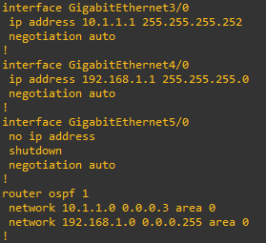

      - To prevent the router from attempting to translate incorrectly entered commands as though they were host names, disable DNS lookup. R1 is shown here as an example.
R1(config)# no ip domain-lookup

Configure OSPF routing on the routers.
      - Use the router ospf command in global configuration mode to enable OSPF on R1.
R1(config)# router ospf 1
      - Configure the network statements for the networks on R1. Use an area ID of 0.
R1(config-router)# network 192.168.1.0 0.0.0.255 area 0
R1(config-router)# network 10.1.1.0 0.0.0.3 area 0
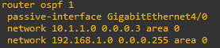
      - Configure OSPF on R2 and R3.
R2(config)# router ospf 1
R2(config-router)# network 10.1.1.0 0.0.0.3 area 0
R2(config-router)# network 10.2.2.0 0.0.0.3 area 0
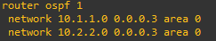
R3(config)# router ospf 1
R3(config-router)# network 10.2.2.0 0.0.0.3 area 0
R3(config-router)# network 192.168.3.0 0.0.0.255 area 0
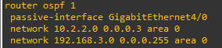
      - Issue the passive-interface command to change the G0/0/1 interface on R1 and R3 to passive.
R1(config)# router ospf 1
R1(config-router)# passive-interface g0/0/1
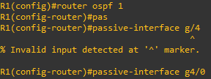
R3(config)# router ospf 1
R3(config-router)# passive-interface g0/0/1
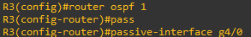

Verify OSPF neighbors and routing information.
      - Issue the show ip ospf neighbor command to verify that each router lists the other routers in the network as neighbors.
R1# show ip ospf neighbor

Neighbor ID Pri State Dead Time Address Interface
10.2.2.2 1 FULL/BDR 00:00:37 10.1.1.2 GigabitEthernet0/0/0
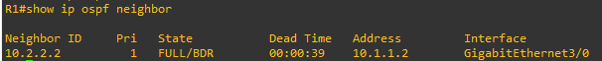
      - Issue the show ip route command to verify that all networks display in the routing table on all routers.
R1# show ip route
Codes: L - local, C - connected, S - static, R - RIP, M - mobile, B - BGP
D - EIGRP, EX - EIGRP external, O - OSPF, IA - OSPF inter area
N1 - OSPF NSSA external type 1, N2 - OSPF NSSA external type 2
E1 - OSPF external type 1, E2 - OSPF external type 2
i - IS-IS, su - IS-IS summary, L1 - IS-IS level-1, L2 - IS-IS level-2
ia - IS-IS inter area, * - candidate default, U - per-user static route
o - ODR, P - periodic downloaded static route, H - NHRP, l - LISP
a - application route
+ - replicated route, % - next hop override, p - overrides from PfR

Gateway of last resort is not set

10.0.0.0/8 is variably subnetted, 3 subnets, 2 masks
C 10.1.1.0/30 is directly connected, GigabitEthernet0/0/0
L 10.1.1.1/32 is directly connected, GigabitEthernet0/0/0
O 10.2.2.0/30 [110/2] via 10.1.1.2, 00:01:11, GigabitEthernet0/0/0
192.168.1.0/24 is variably subnetted, 2 subnets, 2 masks
C 192.168.1.0/24 is directly connected, GigabitEthernet0/0/1
L 192.168.1.1/32 is directly connected, GigabitEthernet0/0/1
- 192.168.3.0/24 [110/3] via 10.1.1.2, 00:01:07, GigabitEthernet0/0/0
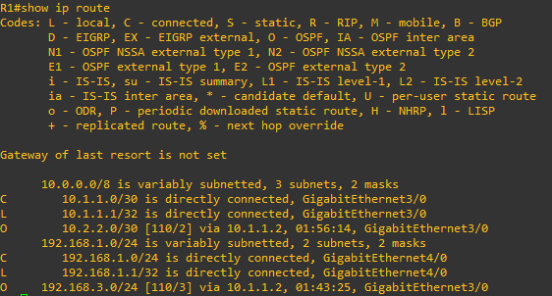

Configure PC host IP settings.
Configure a static IP address, subnet mask, and default gateway for PC-A and PC-C as shown in the IP Addressing Table.
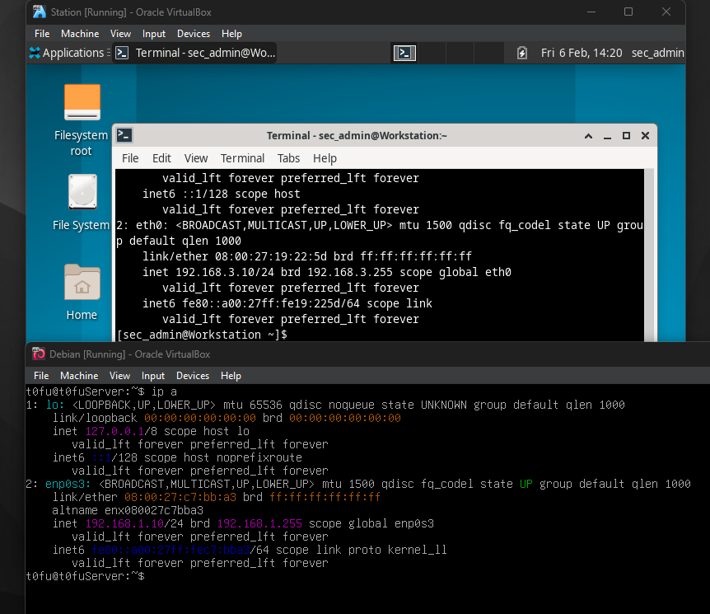

Verify connectivity between PC-A and PC-C.
      - Ping from R1 to R3.
If the pings are not successful, troubleshoot the basic device configurations before continuing.
      - Ping from PC-A, on the R1 LAN, to PC-C, on the R3 LAN.
If the pings are not successful, troubleshoot the basic device configurations before continuing.
Note: If you can ping from PC-A to PC-C you have demonstrated that OSPF routing is configured and functioning correctly. If you cannot ping but the device interfaces are up and IP addresses are correct, use the show run, show ip ospf neighbor, and show ip route commands to help identify routing protocol-related problems.
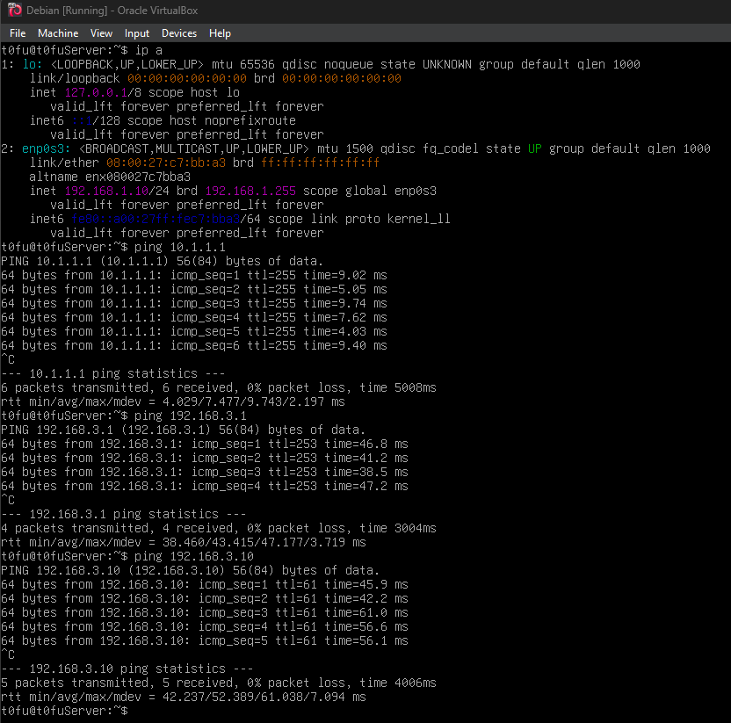
Close configuration window

Configure the PCs.
PC-A will function as the RADIUS server for this lab. A virtual machine with a RADIUS server is setup for use in this course. You can deploy the virtual machine on PC-A by following Lab - Installing the Virtual Machine if you have not done so already. You may choose to download, install, and configure a RADIUS server for your use if desired.
      - Assign the IP address and default gateway on PC-C according to the Addressing Table.
      - If you have not already deployed the virtual machine Security Workstation VM, please go back to Lab - Installing the Virtual Machine.
      - Start VirtualBox and verify that the Security Workstation is using the Bridged Adapter in the Network Settings.
      - Start the Security Workstation VM. Log into the VM as sec_admin with the password net_secPW. Select the user sec_admin from the dropdown list if necessary.
      - From the menu bar at the bottom of the Desktop, click Terminal Emulator.
      - Within the terminal emulator window, you will configure this virtual machine with an IP address of 192.168.1.11 by running a script. When prompted for a password, use the password net_secPW.
[sec_admin@Workstation ~]$ cd ~/lab.support.files/scripts/
[sec_admin@Workstation scripts]$ ./configure_as_static.sh
[sudo] password for sec_admin:
Configuing the NIC as:
IP: 192.168.1.11/24
GW: 192.168.1.1

IP Configuration successful.
      - Enter ip addr at the prompt to verify the assigned static IP address on Security Workstation VM.
[sec_admin@Workstation scripts]$ ip addr
<output omitted>
2: eth0: <BROADCAST,MULTICAST,UP,LOWER_UP> mtu 1500 qdisc fq_codel state UP group default qlen 1000
link/ether 00:50:56:9c:c5:37 brd ff:ff:ff:ff:ff:ff
inet 192.168.1.11/24 brd 192.168.1.255 scope global eth0
valid_lft forever preferred_lft forever
inet6 fe80::250:56ff:fe9c:5248/64 scope link
valid_lft forever preferred_lft forever
      - Ping the gateway IP address (R1's G0/0/0, 192.168.1.1) from Security Workstation VM.
[sec_admin@Workstation scripts]$ ping -c 4 192.168.1.1
PING 192.168.1.1 (192.168.1.1) 56(84) bytes of data.
64 bytes from 192.168.1.1: icmp_seq=1 ttl=255 time=0.605 ms
64 bytes from 192.168.1.1: icmp_seq=2 ttl=255 time=0.661 ms
64 bytes from 192.168.1.1: icmp_seq=3 ttl=255 time=0.654 ms
64 bytes from 192.168.1.1: icmp_seq=4 ttl=255 time=0.641 ms

--- 192.168.1.1 ping statistics ---
4 packets transmitted, 4 received, 0% packet loss, time 3042ms
rtt min/avg/max/mdev = 0.605/0.640/0.661/0.021 ms

Configure Basic Device Settings
In this part, set up the network topology and configure basic settings, such as interface IP addresses.

Cable the network.
Attach the devices, as shown in the topology diagram, and cable as necessary.

Configure basic settings for each router.
Open configuration window
      - Console into the router and enable privileged EXEC mode.
Router> enable
Router# configure terminal
Configure host names as shown in the topology.
R1(config)# hostname R1
Configure interface IP addresses as shown in the IP Addressing Table.
R1(config)# interface g0/0/0
R1(config-if)# ip address 10.1.1.1 255.255.255.0
R1(config-if)# no shutdown

R1(config)# interface g0/0/1
R1(config-if)# ip address 192.168.1.1 255.255.255.0
R1(config-if)# no shutdown


      - To prevent the router from attempting to translate incorrectly entered commands as though they were host names, disable DNS lookup. R1 is shown here as an example.
R1(config)# no ip domain-lookup

Configure OSPF routing on the routers.
      - Use the router ospf command in global configuration mode to enable OSPF on R1.
R1(config)# router ospf 1
      - Configure the network statements for the networks on R1. Use an area ID of 0.
R1(config-router)# network 192.168.1.0 0.0.0.255 area 0
R1(config-router)# network 10.1.1.0 0.0.0.3 area 0

      - Configure OSPF on R2 and R3.
R2(config)# router ospf 1
R2(config-router)# network 10.1.1.0 0.0.0.3 area 0
R2(config-router)# network 10.2.2.0 0.0.0.3 area 0

R3(config)# router ospf 1
R3(config-router)# network 10.2.2.0 0.0.0.3 area 0
R3(config-router)# network 192.168.3.0 0.0.0.255 area 0

      - Issue the passive-interface command to change the G0/0/1 interface on R1 and R3 to passive.
R1(config)# router ospf 1
R1(config-router)# passive-interface g0/0/1

R3(config)# router ospf 1
R3(config-router)# passive-interface g0/0/1


Verify OSPF neighbors and routing information.
      - Issue the show ip ospf neighbor command to verify that each router lists the other routers in the network as neighbors.
R1# show ip ospf neighbor

Neighbor ID Pri State Dead Time Address Interface
10.2.2.2 1 FULL/BDR 00:00:37 10.1.1.2 GigabitEthernet0/0/0

      - Issue the show ip route command to verify that all networks display in the routing table on all routers.
R1# show ip route
Codes: L - local, C - connected, S - static, R - RIP, M - mobile, B - BGP
D - EIGRP, EX - EIGRP external, O - OSPF, IA - OSPF inter area
N1 - OSPF NSSA external type 1, N2 - OSPF NSSA external type 2
E1 - OSPF external type 1, E2 - OSPF external type 2
i - IS-IS, su - IS-IS summary, L1 - IS-IS level-1, L2 - IS-IS level-2
ia - IS-IS inter area, * - candidate default, U - per-user static route
o - ODR, P - periodic downloaded static route, H - NHRP, l - LISP
a - application route
+ - replicated route, % - next hop override, p - overrides from PfR

Gateway of last resort is not set

10.0.0.0/8 is variably subnetted, 3 subnets, 2 masks
C 10.1.1.0/30 is directly connected, GigabitEthernet0/0/0
L 10.1.1.1/32 is directly connected, GigabitEthernet0/0/0
O 10.2.2.0/30 [110/2] via 10.1.1.2, 00:01:11, GigabitEthernet0/0/0
192.168.1.0/24 is variably subnetted, 2 subnets, 2 masks
C 192.168.1.0/24 is directly connected, GigabitEthernet0/0/1
L 192.168.1.1/32 is directly connected, GigabitEthernet0/0/1
- 192.168.3.0/24 [110/3] via 10.1.1.2, 00:01:07, GigabitEthernet0/0/0


Configure PC host IP settings.
Configure a static IP address, subnet mask, and default gateway for PC-A and PC-C as shown in the IP Addressing Table.


Verify connectivity between PC-A and PC-C.
      - Ping from R1 to R3.
If the pings are not successful, troubleshoot the basic device configurations before continuing.
      - Ping from PC-A, on the R1 LAN, to PC-C, on the R3 LAN.
If the pings are not successful, troubleshoot the basic device configurations before continuing.
Note: If you can ping from PC-A to PC-C you have demonstrated that OSPF routing is configured and functioning correctly. If you cannot ping but the device interfaces are up and IP addresses are correct, use the show run, show ip ospf neighbor, and show ip route commands to help identify routing protocol-related problems.
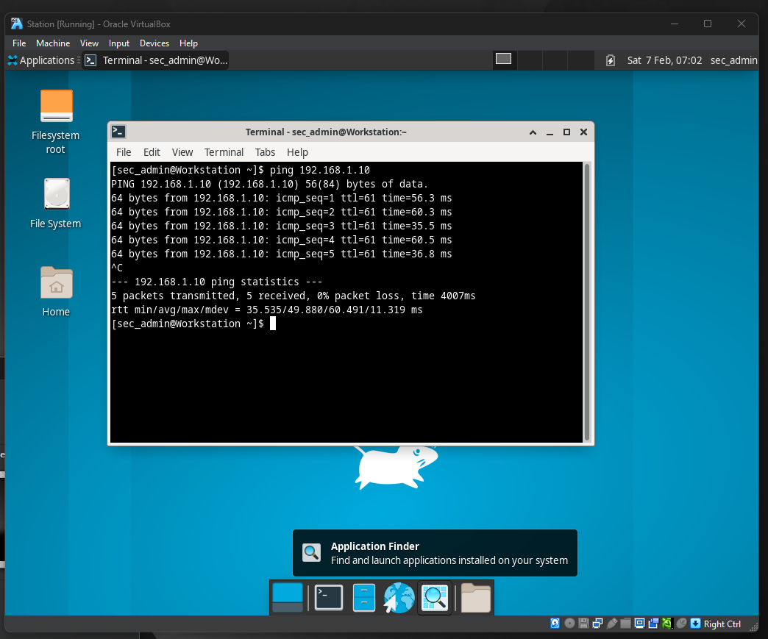

Verify connectivity.
      - Test connectivity by pinging from Security Workstation VM to PC-C. If the pings are not successful, troubleshoot the router and PC configurations until they are.
      - From Security Workstation VM terminal, establish an SSH session with R1 using the username user01 and password user01pass. Enter yes when prompted if you are sure you want to continue connecting.
[sec_admin@Workstation scripts]$ ssh -l user01 192.168.1.1
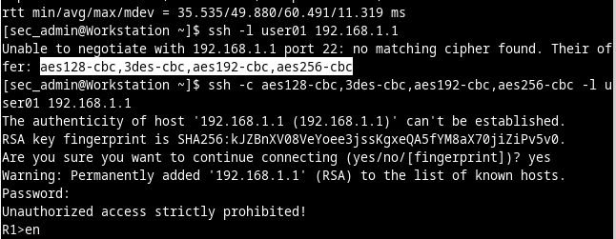
      - Exit the SSH session when finished. Establish another SSH with R1 using the username admin and password cisco12345.
      - Exit the SSH session when finished. Now you have verified end-to-end connectivity and Security Workstation VM can communicate with router R1.
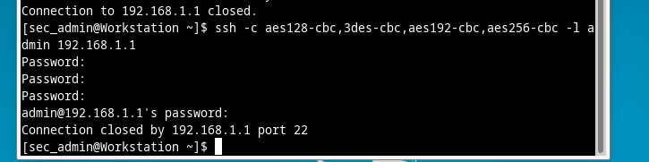

Configure Centralized Authentication Using AAA and RADIUS
In this part, you will configure R1 to use AAA services to authenticate users. The RADIUS server is already configured with one user RadUser with the password RadUserpass and the secret shared key $trongKey.
Open configuration window

Enable AAA on R1.
Open a console on R1 and use the aaa new-model command in global configuration mode to enable AAA.
R1(config)# aaa new-model

Configure the default login authentication list.
Configure the list to first use RADIUS for the authentication service, and then the fallback, none. If no RADIUS server can be reached and authentication cannot be performed, the router globally allows access without authentication. This is a safeguard measure in case the router starts up without connectivity to an active RADIUS server.
R1(config)# aaa authentication login default group radius none
Note: You could alternatively configure local authentication as the backup authentication method.
Note: If you do not set up a default login authentication list, you could get locked out of the router and need to use the password recovery procedure for your specific router.

Specify a RADIUS server.
      - Use the radius server command to enter RADIUS server configuration mode.
R1(config)# radius server NetSec
      - Use the ? to view the sub-mode commands available for configuring a RADIUS server.
R1(config-radius-server)# ?
RADIUS server sub-mode commands:
address Specify the radius server address
automate-tester Configure server automated testing.
backoff Retry backoff pattern(Default is retransmits with constant
delay)
exit Exit from RADIUS server configuration mode
key Per-server encryption key
no Negate a command or set its defaults
non-standard Attributes to be parsed that violate RADIUS standard
pac Protected Access Credential key
retransmit Number of retries to active server (overrides default)
timeout Time to wait (in seconds) for this radius server to reply
(overrides default)
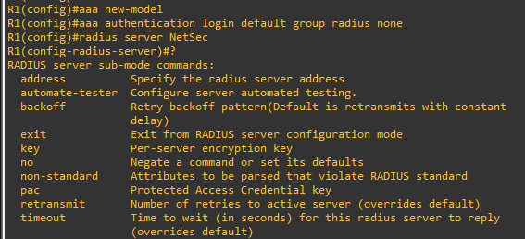
      - Use the address command to configure the IP address of the RADIUS server.
R1(config-radius-server)# address ipv4 192.168.1.11
      - The key command is used for the secret password that is shared between the RADIUS server and the router (R1 in this case) and is used to authenticate the connection between the router and the server before the user authentication process takes place. Use the secret password of $trongPass that has been configured on the Radius server. Remember that passwords are case-sensitive.
R1(config-radius-server)# key $trongPass
R1(config-radius-server)# end
Close configuration window
Note: For the purposes of this lab, an unencrypted password is configured. In the future, IOS will require encrypted passwords.

Test the AAA RADIUS Configuration.

Start the RADIUS Server and verify operation.
      - At the Security Workstation terminal, start the RADIUS server by entering the sudo systemctl start freeradius.service command. Enter the password net_secPW as necessary.
[sec_admin@Workstation ~]$ sudo systemctl start freeradius.service
      - Verify that the server is running, enter the command sudo systemctl status freeradius.service at the terminal prompt.
[sec_admin@Workstation ~]$ sudo systemctl status freeradius.service
? freeradius.service - FreeRADIUS high performance RADIUS server.
Loaded: loaded (/usr/lib/systemd/system/freeradius.service; disabled; vendor preset: disabled)
Active: active (running) since Sun 2021-02-14 22:14:07 EST; 18min ago
Docs: man:radiusd(8)
man:radiusd.conf(5)
https://wiki.freeradius.org/Home
https://networkradius.com/freeradius-documentation/
Process: 890 ExecStartPre=/usr/bin/radiusd -C (code=exited, status=0/SUCCESS)
Process: 893 ExecStart=/usr/bin/radiusd -d /etc/raddb (code=exited, status=0/SUCCESS)
Main PID: 895 (radiusd)
Tasks: 6 (limit: 1113)
Memory: 77.5M
CGroup: /system.slice/freeradius.service
mq895 /usr/bin/radiusd -d /etc/raddb

Feb 14 22:14:07 Workstation systemd[1]: Starting FreeRADIUS high performance RADIUS server....
Feb 14 22:14:07 Workstation systemd[1]: Started FreeRADIUS high performance RADIUS server..
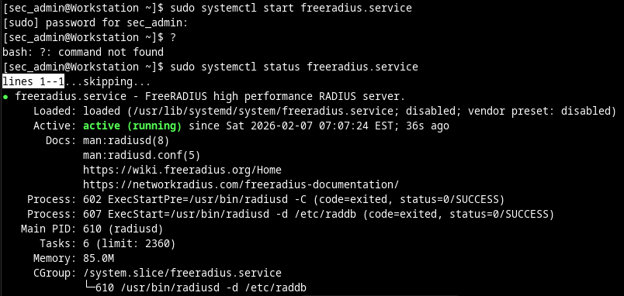

Test your configuration.
You can test and verify your RADIUS server configurations on your router before exiting the router by using the test aaa command. The output message indicates that there is no authoritative response from the RADIUS sever.
Open configuration window
R1# test aaa group radius RadUser RadUserpass legacy
Attempting authentication test to server-group radius using radius
No authoritative response from any server
You may also see messages similar to the following may display after the attempted tests indicating that the RADIUS server at 192.168.1.11 is not communicating with the router.
*Feb 15 02:30:26.504: %RADIUS-4-RADIUS_DEAD: RADIUS server 192.168.1.11:1645,1646 is not responding.
*Feb 15 02:30:26.504: %RADIUS-4-RADIUS_ALIVE: RADIUS server 192.168.1.11:1645,1646 is being marked alive.
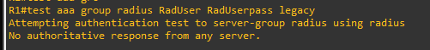

Troubleshoot router-to-RADIUS server communication.
The show radius server-group radius command indicates that the router is using UDP ports 1645 and 1646 for communications.
R1# show radius server-group radius
Server group radius
Sharecount = 1 sg_unconfigured = FALSE
Type = standard Memlocks = 1
Server(192.168.1.11:1645,1646) Transactions:
Authen: 32 Author: 0 Acct: 0
Server_auto_test_enabled: FALSE
Keywrap enabled: FALSE
RFC 2865 officially assigned port numbers 1812 and 1813 for RADIUS. This indicates that the router and RADIUS server are not communicating on the same ports.
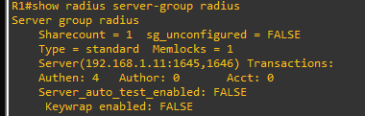

Change the RADIUS port numbers on R1 to match the RADIUS server.
Unless specified otherwise, the Cisco IOS RADIUS configuration defaults to UDP port numbers 1645 and 1646. Either the router Cisco IOS port numbers must be changed to match the port number of the RADIUS server or the RADIUS server port numbers must be changed to match the port numbers of the Cisco IOS router.
      - Re-issue the address sub-mode command again. This time specify port numbers 1812 and 1813, along with the IPv4 address.
R1(config)# radius server NetSec
R1(config-radius-server)# address ipv4 192.168.1.11 auth-port 1812 acct-port 1813
      - Test the router to RADIUS server communications again by using the test aaa command.
R1# test aaa group radius RadUser RadUserpass legacy
Attempting authentication test to server-group radius using radius
User was successfully authenticated.
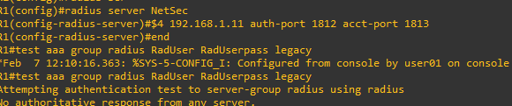

Test your configuration by logging into the console on R1.
      - Exit to the initial router screen that displays: R1 con0 is now available, Press RETURN to get started.
      - Log in again with the username of RadUser and password of RadUserpass.

Question:
Were you able to login? Was there any delay this time?
Yes, and there was negligible delay as R1 was able to access the RADIUS server to validate the username and password
Type your answers here.
      - Log in again using an invalid username of Userxxx and the password of Userxxxpass.

Questions:
Were you able to login?
No. R1 accessed the RADIUS server and validation failedType your answers here.
What message was displayed on the router?
% Authentication failedType your answers here.
      - Log in again using the local user credentials, admin / cisco12345 or user01 / user01pass.

Question:
Were you able to log in? Explain.
You will not be able to log in because the user credentials are not configured on the RADIUS server at 192.168.1.11. While the RADIUS server is functioning, you will not be able to authenticate using the credentials from the local user database
Type your answers here.

Create an authentication method list for SSH and test it.
      - Log back into R1 as necessary.
      - Create a unique authentication method list for SSH access to the router. This does not have the fallback of no authentication, so if there is no access to the RADIUS server, SSH access is disabled. Name the authentication method list SSH_LINES.
R1(config)# aaa authentication login SSH_LINES group radius
      - Apply the list to the vty lines on the router using the login authentication command.
R1(config)# line vty 0 4
R1(config-line)# login authentication SSH_LINES
      - Establish an SSH session from PC-C to R1 (10.1.1.1) and log in with the username RadUser and the password of RadUserpass. Were you able to gain access to log in? Explain.
Yes. R1 contacted the RDIUS server for user authentication, and a valid username/password combination was entered on R1
Type your answers here.
Establish an SSH session from PC-C to R1 again. Log in with the username user01 and the password of user01pass. Were you able to log in? Explain.
No. R1 contacted the RADIUS server for user authentication, and the username/password combination was not defined in the RADIUS database, so access is not granted

Type your answers here.
Close configuration window

Reflection
  - Why would an organization want to use a centralized authentication server rather than configuring users and passwords on each individual router?
Centralized authentication is more scalable than updating local device databases, significantly reducing administrative overhead for user management, especially in large networks
Type your answers here.
  - Contrast local authentication and local authentication with AAA.
Local router authentication uses a local database for username/password prompts on console, VTY, and AUX lines. AAA provides enhanced control, enabling the use of this local database for logins while allowing for configurable fallback procedures
Type your answers here.

Router Interface Summary Table
Router Model | Ethernet Interface #1 | Ethernet Interface #2 | Serial Interface #1 | Serial Interface #2
1900 | Gigabit Ethernet 0/0 (G0/0) | Gigabit Ethernet 0/1 (G0/1) | Serial 0/0/0 (S0/0/0) | Serial 0/0/1 (S0/0/1)
2900 | Gigabit Ethernet 0/0 (G0/0) | Gigabit Ethernet 0/1 (G0/1) | Serial 0/0/0 (S0/0/0) | Serial 0/0/1 (S0/0/1)
4221 | Gigabit Ethernet 0/0/0 (G0/0/0) | Gigabit Ethernet 0/0/1 (G0/0/1) | Serial 0/1/0 (S0/1/0) | Serial 0/1/1 (S0/1/1)
4300 | Gigabit Ethernet 0/0/0 (G0/0/0) | Gigabit Ethernet 0/0/1 (G0/0/1) | Serial 0/1/0 (S0/1/0) | Serial 0/1/1 (S0/1/1)
Blank Line, No additional information
Note: To find out how the router is configured, look at the interfaces to identify the type of router and how many interfaces the router has. There is no way to effectively list all the combinations of configurations for each router class. This table includes identifiers for the possible combinations of Ethernet and Serial interfaces in the device. The table does not include any other type of interface, even though a specific router may contain one. An example of this might be an ISDN BRI interface. The string in parenthesis is the legal abbreviation that can be used in Cisco IOS commands to represent the interface.
end of document

